LOURDES CATHOLIC SCHOOL
BREAKFAST AND LUNCH MENU
JANUARY 2025 K-12

MONDAY 20 | TUESDAY 21 | WEDNESDAY 22 | THURSDAY 23 | FRIDAY 24
BREAKFAST  NO  CLASSES | BREAKFAST  EGG & CHEESE BURRITOS  BEANS  YOGURT  APPLES  PINEAPPLE  MILK VARIETY | BREAKFAST  BAGEL W/ CREAM CHEESE  MIXED FRUIT  YOGURT & GRANOLA  MILK VARIETY | BREAKFAST  CREAM OF WHEAT  BANANAS  APPLES  YOGURT  MILK VARIETY | BREAKFAST  CHILAQUILES  BEANS  CANTALOUPE  ORANGES  MILK VARIETY
LUNCH  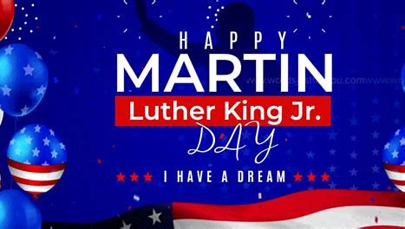 | LUNCH  BEEF NACHOS  CORN  CANTALOUPE  PEACHES  MILK VARIETY | LUNCH  HOT DOGS  FRENCH FRIES  SALSA BANDERA  MIXED FRUIT  APPLES  MILK VARIETY | LUNCH  TINGA TACOS  BEANS  LETTUCE & SALSA  ORANGES  APPLE SAUCE  MILK VARIETY | LUNCH  CHICKEN STRIPS  SLICED POTATOES  GARDEN SALAD  CANTALOUPE  HONEYDEW MELON  MILK VARIETY

THIS INSTITUTION IS AN EQUAL OPPORTUNITY PROVIDER

